Second National Testing weekend:
Firstly, my thanks to all those who helped in organizing the weekend, it gave all the athletes and coaches an excellent opportunity to see the results of their Autumn training. It was also the first chance to see the returning USA team performing on home water.

6km ergo test:
The % result is calculated off 3x the world best 2k score- so certainly a very tough number but it does give a good guide and comparison between the different categories.
If you combine all the categories then the top 10 is dominated by the Lightweight men – congratulations to J Vetesnik with the top % - but of particular note was J Podrazil who was clear at the top of the Heavyweight men.
The aim of the 6km ergo is to see how well physical training is progressing, - we know ergos do not float- but, without good power and endurance the water results will always be limited and we must continue to develop this aspect of our training.

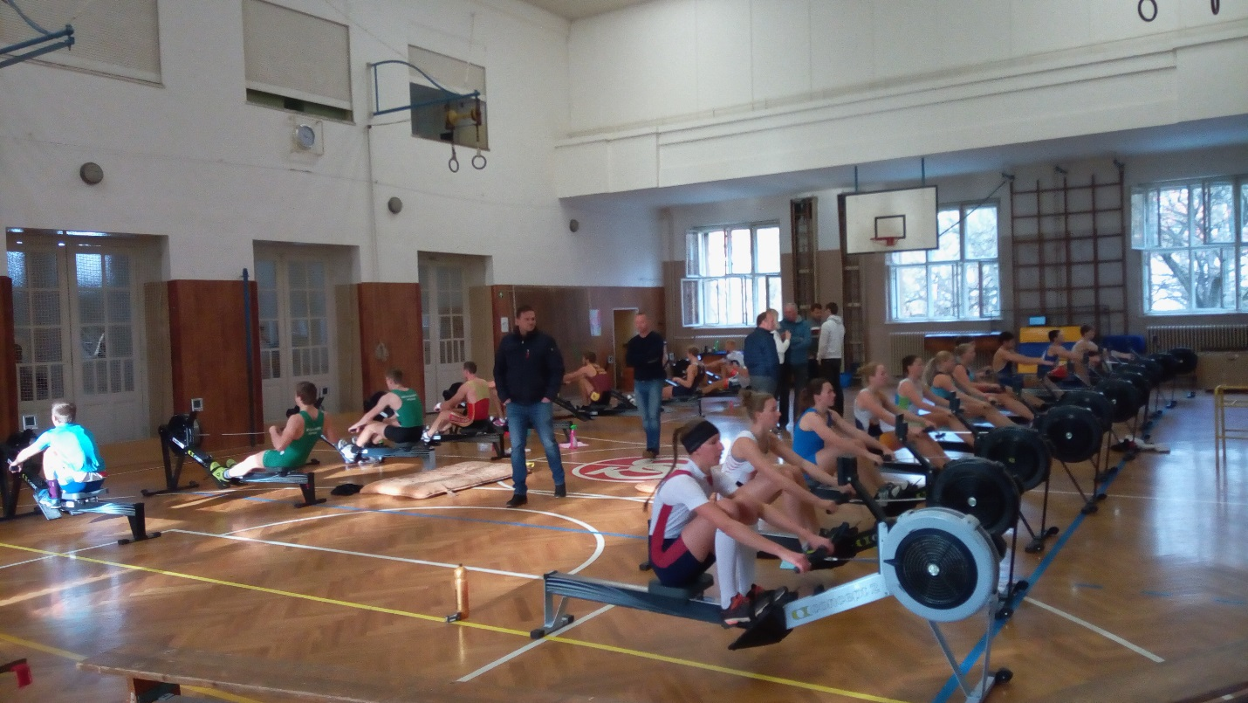

5.6km Water test:
The conditions were good and fast, with a nice following wind. My impression was that the racing was more intense than the first test with some close finishes in the different groups.
The % were again dominated by the Lightweight men- congratulations J Cincibuch - but of note was
K Neuhortova finishing a long way clear of the rest of the lightweight women, J Podrazil making a good change from his summer racing boat, the pair, to also win the men’s single and L Antosova a clear step ahead in the women’s category.
Overall it was a good weekend of testing which importantly gives both athletes and coaches information to help with their training and the incentive to continue with good work over the coming months. This is the key point from the testing, seeing how you performed from the training you were doing.
Some points to consider:
- Did you manage to show your good training under race conditions?
- Have you improved since the last test?
- How much did the test make you change your training?
Look to answer these questions with your coach and move forward, this test was certainly not a final selection but a part of the process to build a picture of your progress and current level

Going forward:
The next official test is the 6km at rate 24, this must be done between the 27th and 31st December. The test should be completed in the Clubs and a screen shot showing both time and average rate should be submitted to Michal Vabrousek michalvabrousek@gmail.com .
The aim of the test is to give a focus to the training over this period when training can drift with the distractions of the holiday season and to ensure good base training continues, the rate 24 is to encourage long accelerated strokes.
The test should not disrupt the training rhythm but be a part of ensuring some good quality work as well as volume is being practiced at this time.

Please contact me if there are any questions about the latest test or the next months.
I wish you all continued good training.

Simon Cox
Performance Director.

