What’s been happening and what’s next?

Over the past weeks the current top athletes have been on various training camps,

- Some Senior A men were cross country skiing at altitude where the temperature was down to minus 15.
- The women’s center U23 athletes were water training in Sabaudia where they took the opportunity to work on general fitness and build up some more water kms in their skiffs.
- A mix of the SA women, lightweight men and remaining heavyweights were at a new location in Mallorca working on their gym skills and base fitness levels.

The Mallorca camp was based on bikes to hold a good volume of training:
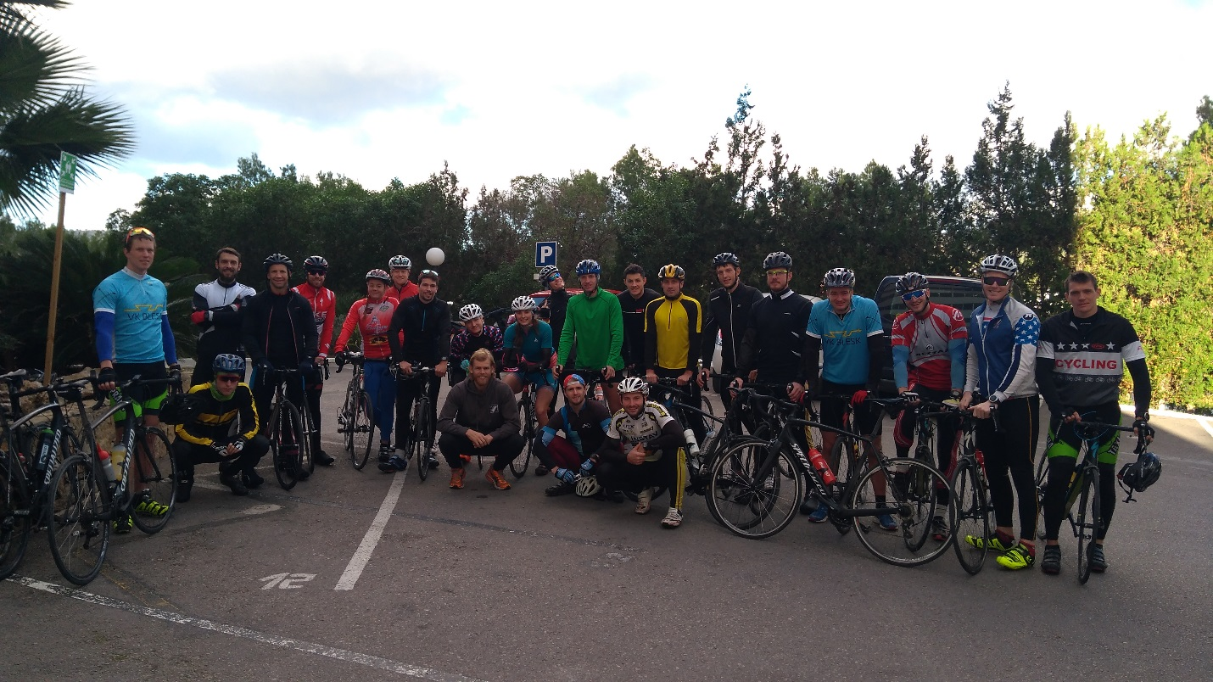

On the ten-day camp over 20 hours were spent on the bike, with some good hill climbs and close competition on the flatter stages. Despite some different skill levels all the athletes completed a good volume of work.
Alongside the work out on the road there were at least one or two gym sessions per day, some focusing on teaching and improving techniques, others used to build speed and intensity into the training.
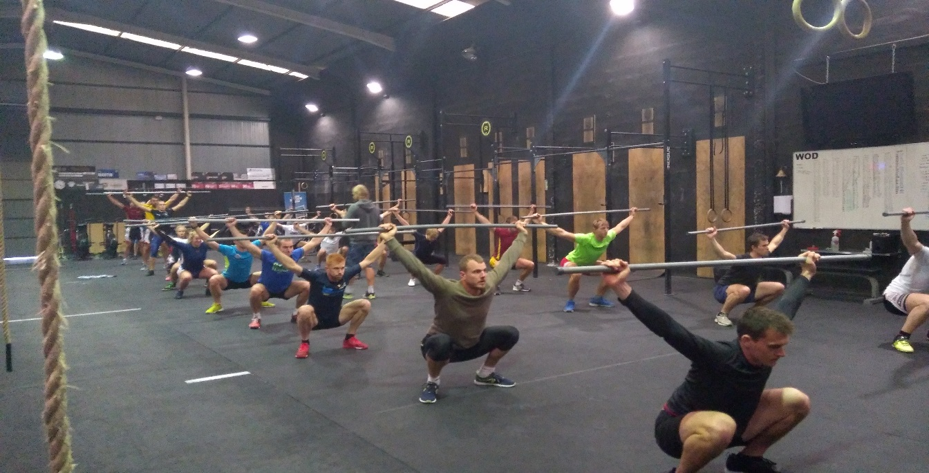

Over 30 hours of training were completed in seven days and our thanks got to Rob and Janis at Cross fit Mallorca for their help in organizing the training, back up and sunshine enjoyed by the team.
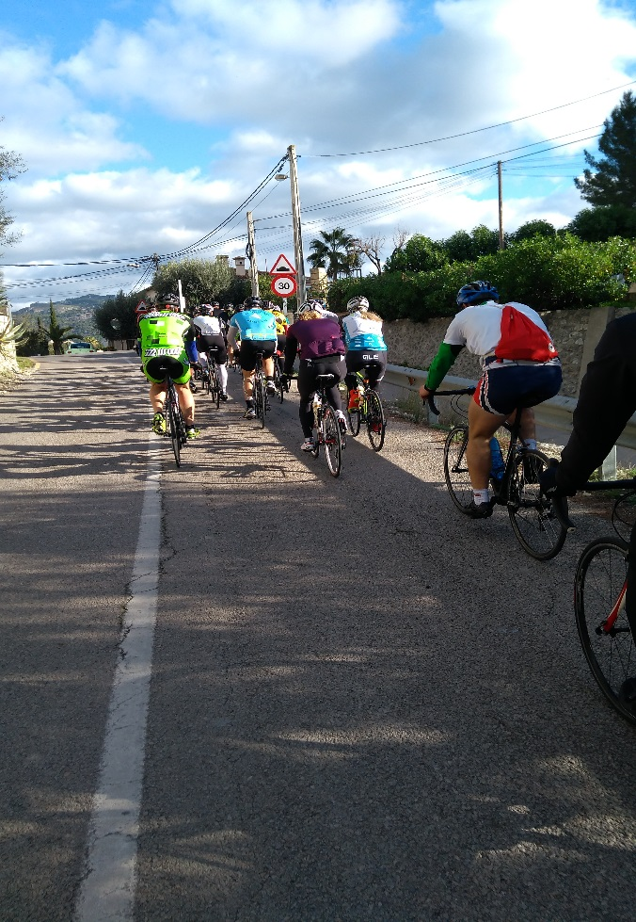

What’s next:
For potential National Team athletes:
- 6km ergo test at rate 24. This test is to encourage good winter training of long powerful strokes. It should be done on the stationary ergo and a screen shot sent to Michal Vabrousek at: michalvabrousek@gmail.com. This test should be undertaken as a part of training and it is not necessary to greatly change the training focus to do it. There is a window for the test between Christmas and New Year.
- 2km ergo tests. The Czech ergo Championships have already started with the first event taking place on the 9th December. It is necessary to produce a score under the published limits for your category at one of the 3 regional or the final on the 18th February. As has already been published I may, upon agreement, accept scores that have been performed outside of these events – but only on prior agreement and with appropriate witnesses.
- The ergo limits are there as a realistic minimum to show that you have the physical capacity and are training appropriately to be able to race internationally. If you are struggling or unable to break these limits then you need to discuss with your coach your training and whether your international ambitions are realistic at this time. The ergo does not select you but enable a potential invitation to trials which will be given in conjunction with the water results.

Training camps:
The Lightweight women’s group is the next away for a ski camp over the Christmas period, followed by the men who return to their skis at altitude.

Finally- I wish you all a good Christmas and look forward to seeing you fitter and faster in 2018 as we work towards our goals over the coming season.
As ever, if there are questions please feel free to contact me.

Simon Cox
Performance Director
December 2017

