Back in the groove….
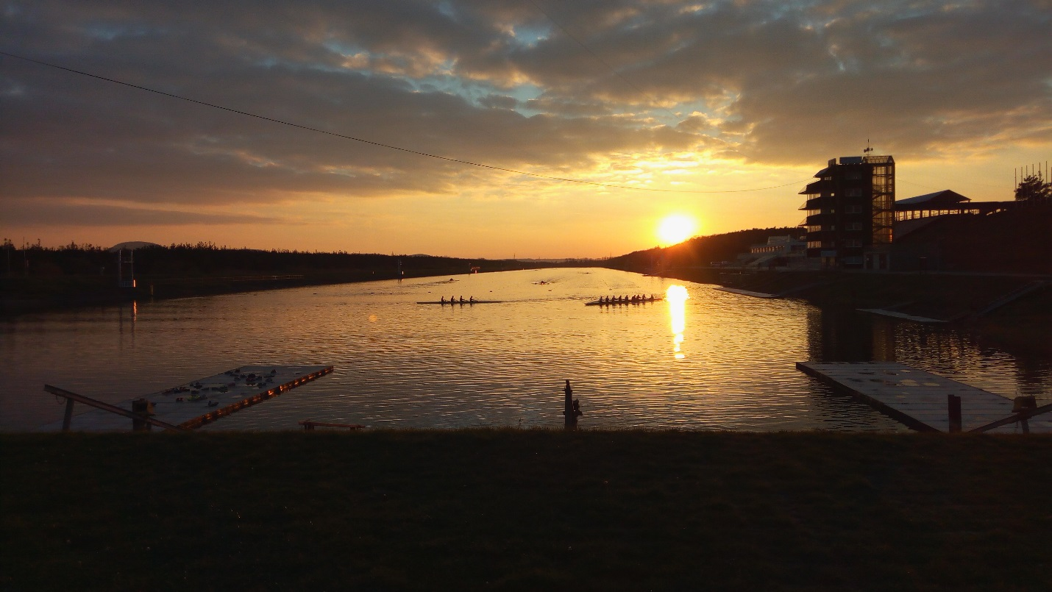
The returning National Team athletes, invited participants and those competing for VSCM places met over the weekend 3,4,5 November for some training and basic physical testing.

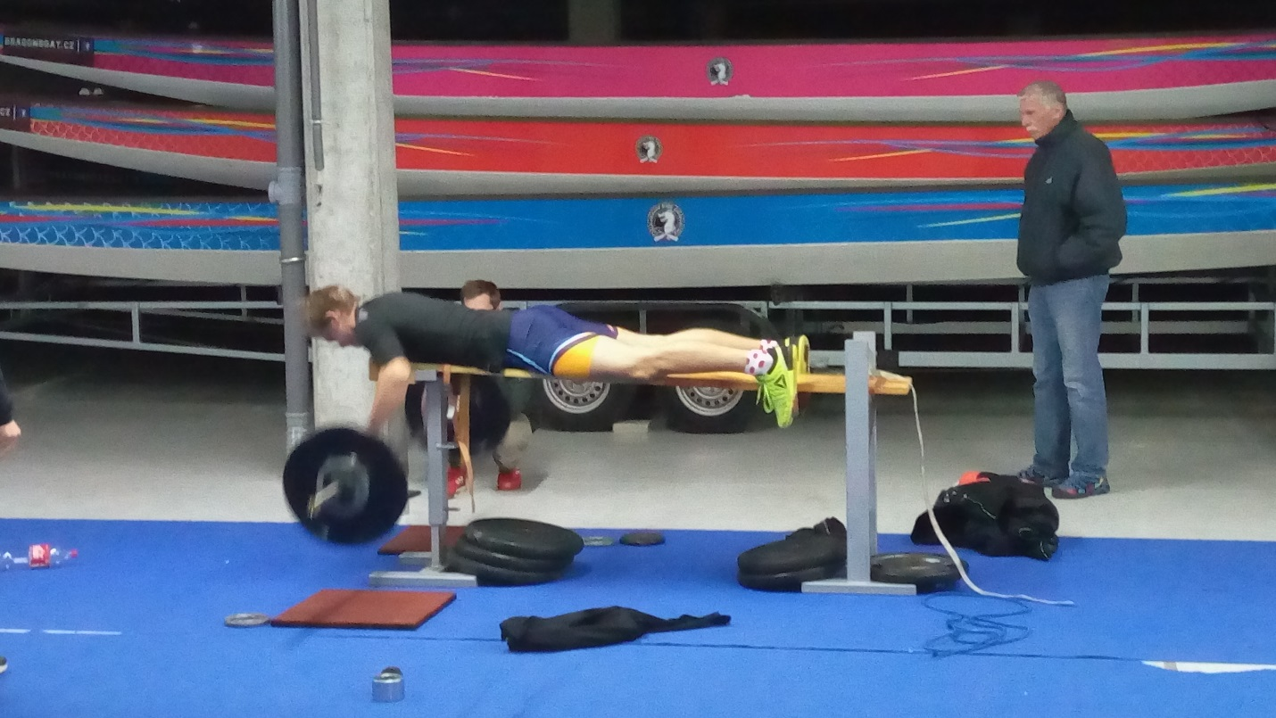
It was an excellent training weekend, blessed with beautiful flat-water conditions and an opportunity to do some crew boat training and competitive pieces. The on-water work was a perfect way for the athletes returning from their recent efforts at the World Championships to be re-integrated into the basic training required over the next months.
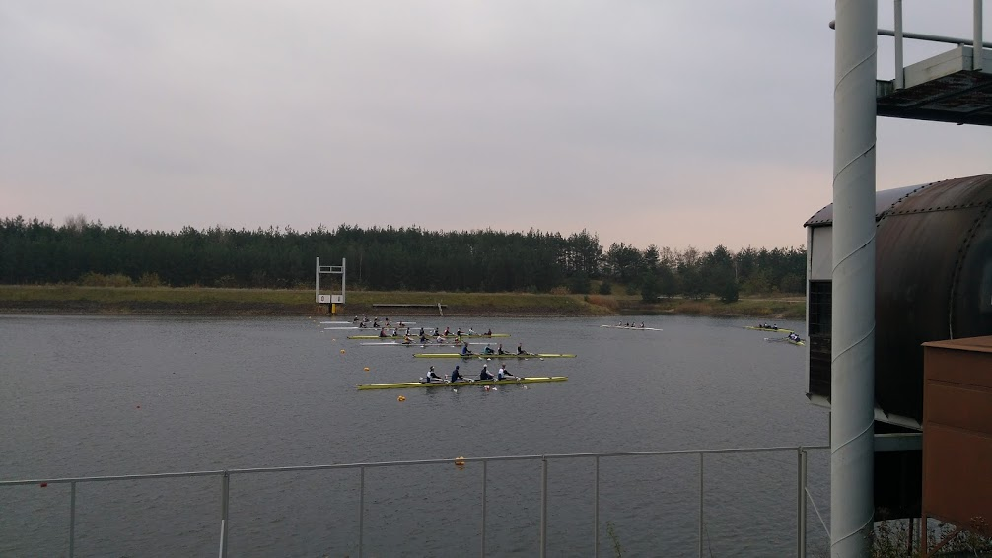
The testing took many different forms to encourage and check all round athletic ability. Variety of training and athletic ability is now an essential part of any modern training program not only to work on body rebalancing and injury prevention but to ensure different mental stimulation as the volume of the program increases.
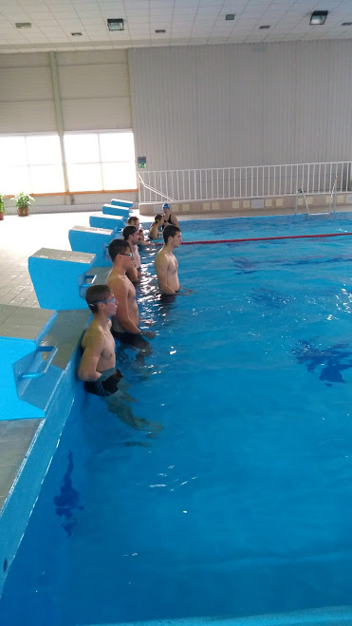
The athletes were tested in swimming (200m), running (3km), 5’ bench pull test (40% body weight), static vertical jump (3 attempts) and a 3x3 cleans test with 2’ rest.
The top all round athletes were Lenka Antosova and Petr Melichar, congratulations to them both.
The athletes all have their own individual scores which they can now work at improving and use as a check on physical progress or as alternative sessions when there are no other training possibilities.

There was learning for the coaches as well, with the services of Zdenek from Xfit Praha, who gave the coaching team a refresher and reminders of the key points to watch out for to ensure safe and effective weight training, training that should be an integral part of any balanced training program and practiced by all successful rowing nations.
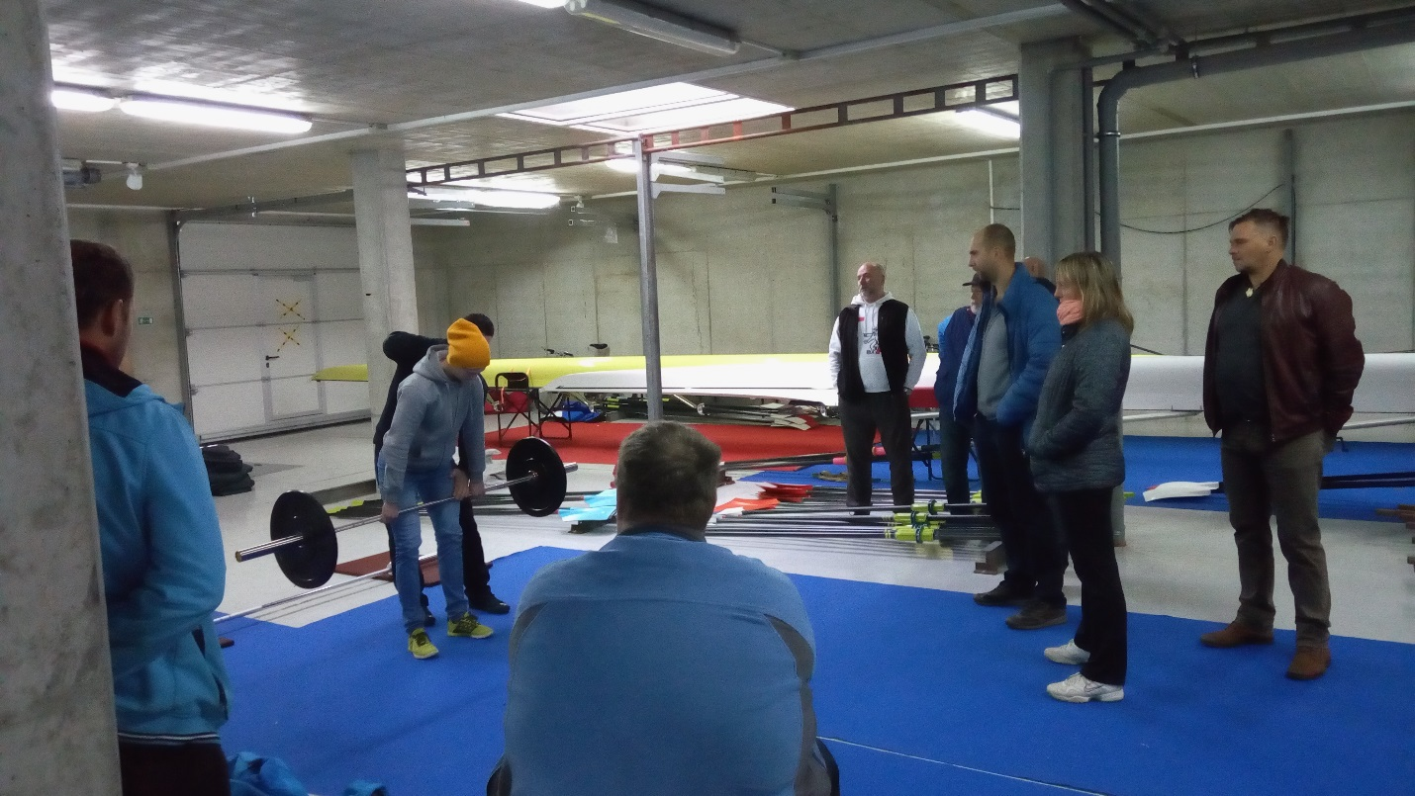

It was an excellent starting point for setting ideas and some benchmarks for the coming winter months and my thanks goes to the coaches and everyone involved in helping make it a positive experience for the athletes.

Simon Cox
Performance Director

